


Jacob Waugh
3D Artist JacobWaugh.com
(919) 999-7813
Jacob@Waughhoo.com
6005 Meadow Run Ct.
Chapel Hill, NC 27516

“I’m looking to put my skills to work in new environments,
pushing myself and my art to the next level”

Technical Skills

Program Experience:
- Maya
  - Modeling (Example)
  - Animating (Example)
- ZBrush (Example)
- Unity
- Unreal Engine 4/5
- Photoshop
- Illustrator
- Premiere Pro
- Excel
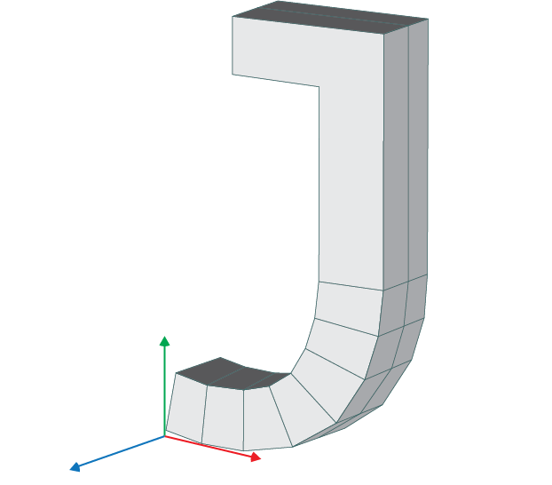

Education

Wake Technical Community College (Sept. 2023 – Present)
- Working towards an associate’s degree in Simulation & Game Development (Art & Modeling)

Work Experience

Chick-fil-a (Feb 2022 – Aug 2022)
- Worked as front of house staff
- Gained experience working in a team in a fast paced environment, following through on requests, and managing supplies

Carolina Athletic Hospitality @ Kenan Memorial Stadium (Jul 2023 – Jan 2024)
- Worked helping guests in premium seating areas
- Gained experience working as part of a much larger team, helping give information to guests, as well as serving as a connection between different areas of the stadium.

